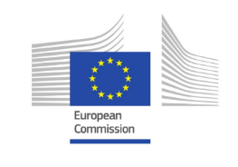
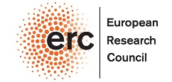
Summer School 2020

BAYES BY THE SEA

Rationality and Strategic Interaction in the Sciences
Ancona (Italy), 20th – 23rd July 2020

Università Politecnica delle Marche, Ancona

This event is financed by Philpharm project, that has received funding from the European Research Council (ERC) under the European Union's Horizon 2020 research and innovation programme – G.A. n. 639276

REGISTRATION FORM

Name.……………………………………………………………………………………..
Family Name.…………………………………………………………..........................
Date and Place of Birth………………………………..………………………………...
Address….………………………………………………………………………………..
Nationality………………………………………………………………………………...
Passport no………………………………………………………………………………
Email…. …………………………………………………………………………………..

FEE

The registration is valid after the payment of the participation fee of 250,00 Euros to:

Dipartimento di Scienze Biomediche e Sanità Pubblica
Università Politecnica delle Marche - Ancona

Bank: UNICREDIT S.p.A. – Agenzia di ANCONA TORRETTE
Bank account N°: 000040032481
BIC SWIFT: UNCRITM1Q11
IBAN: IT 95 J 02008 02640 000040032481

Please indicate “Bayes by the sea summer school 2020” as reason for the payment.

DISBSP - Dipartimento di Scienze Biomediche e Sanità Pubblica Via Tronto, 10/a
60020 ANCONA, Italia
www.univpm.it

